Acoustofluidics Forum
(9th SIG Meeting of The Acoustofluidics in Fluidic Network)

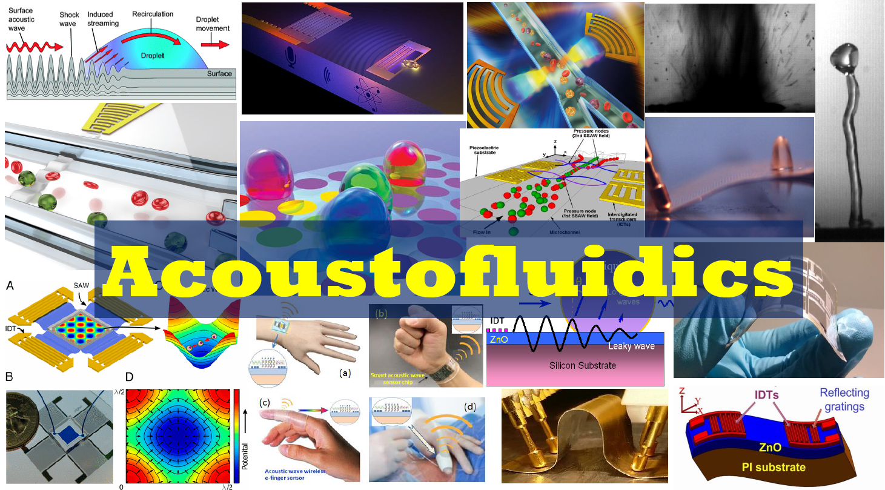

Date:
16-17 October 2019

Location:
Committee Room 2, Glamorgan Building, Cardiff University
King Edward VII Ave, Cardiff CF10 3NN
The map can be found on: https://goo.gl/maps/w8YJgZY9vmEZRqKK6

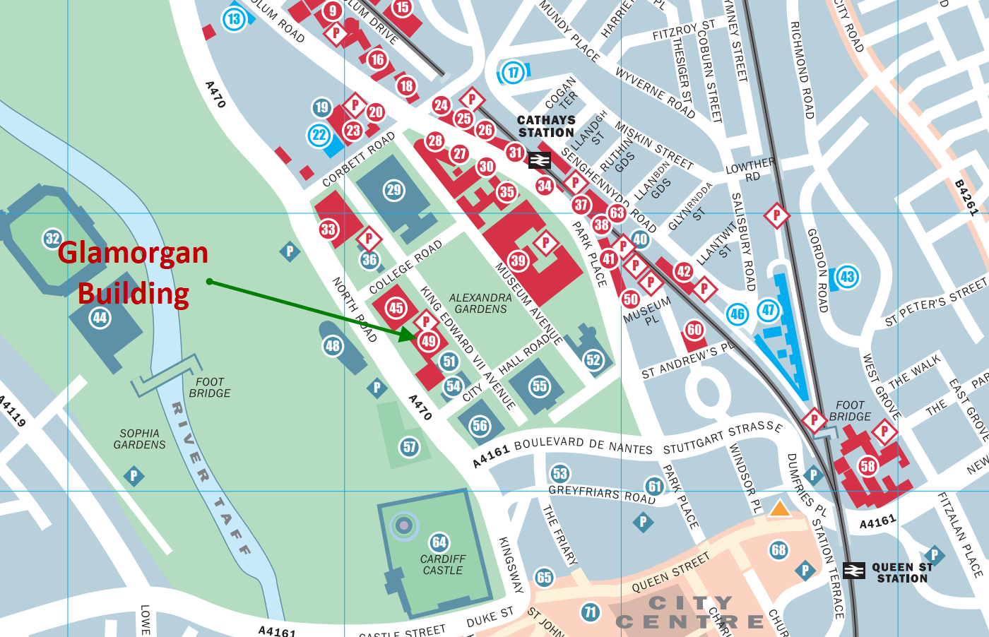

Programme
Day 1 – 16 October, Wednesday, 2019
Time | Speaker | Institute | Title
10.00 – 10.20 | Registration (Coffee & Tea)
10:20-10:25 | Dr Xin Yang | Cardiff University | Welcome and safety
10:25-10:30 | Prof. Richard fu | Northumbria University | Future plan after UKFN
10:30-11.15 | Prof Bruce Drinkwater | University of Bristol | The power of design simplicity - exploring new applications for bulk wave acoustic manipulation devices
11.15-12.00 | Dr Xin Yang | Cardiff University | Acoustic Tweezers Based on GaN
12.00-12.30 | Dr Caroline Pouya | University of Exeter | The Frequency Dependence of Surface Acoustic Wave Swimming
12.30-13.00 | Mr Fangda Wu | Cardiff University | SAW washing electroporated cells
13.00-14.00 | Lunch and networking (with Group Photo)
14.00-14.45 | Prof Martyn Hill | University of Southampton | TBC
14.45-15.30 | Dr Julien Reboud | University of Glasgow | What is to come next in acoustofluidics
15.30-16.00 | Mr Roman Mikhaylov | Cardiff University | PCB-based SAW acoustic tweezers
16.00-16.30 | Dr Cristiano Palego | Bangor University | Micro-optofluidic chip for discrimination and treatment of cancer stem cells with ultra-high frequency signals
16.30-17.00 | Dr Liangfei Tian | University of Bristol | Ultrasound wave: an emerging tool in micro-array technologies
17.00-19.00 | Cheese and Wine

Day 2 – 17 October, Thursday, 2019
Time | Speaker | Institute | Title
9.30-10.00 | Coffee & Tea
10.00-10.30 | Prof Richard Fu | Northumbria University | Flexible and wearable acoustofluidics lab-on-chips
10.30-11.00 | Dr Jeremy Hawkes | UK | Ultrasound standing wave filters
11.00-11.30 | Dr Yinhua Dong | Cardiff University | Cell stimulation based on PCB SAW devices
11.30-12.00 | Dr Hamdi Torun | Northumbria University | An integrated platform combining acoustofluidics and electromagnetic metamaterials
12.00-12.30 | Dr Yulia Hicks | Cardiff University | Ultrasound imaging for measuring cardiac outputs
12.30-13.30 | Lunch and networking
13.30-14.00 | Dr Rhys Pullin | Cardiff University | Advanced Damage Detection and Characterisation using Acoustic Emission
14.00-14.30 | Dr Christian Burton | Cardiff University | Exosome diagnostics using SAW
14.30-15.00 | Dr You Zhou | Cardiff University | Lipid, liver and life: an integrative approach
15.00-15.20 | Ms Sadaf Maramizonouz | Northumbria University | Numerical simulation of acoustic streaming in microchannel
15.30 | Final remarks and Closure

Finances
The UKFN will provide us with limited funding, but it will be mainly used to cover refreshments and lunch, and reasonable expenses for the travel of invited speakers. We may provide some funding for students from our SIG members to fund their travel expenses. If you need to have funding support, please contact Dr Chris Yang yangx26@cardiff.ac.uk or Prof Richard Fu Richard.fu@northumbria.ac.uk in advance.

Who May Attend
All members of the SIG, especially junior academic staff, Research Fellows, post-doc researchers or PhD students are invited.

Confirming Attendance
For attendance, please reply to yangx26@cardiff.ac.uk.

We’d appreciate replies whether you can attend or not. This will help us with room sizes and catering. Please indicate any dietary matters we need to consider for lunch (vegetarian/vegan/gluten-free, etc).

